|  |  |
| --- | --- |
| **Ex No: 5**  **Date: 04-09-2024** | **Transfer Learning** |

**Objective:**

The objective of this lab is to build a flower classification model using the MobileNet V2 pre-trained model from TensorFlow Hub. The model will classify different types of flowers (daisy, dandelion, roses, sunflowers, and tulips) using transfer learning. We will preprocess the dataset, train the model, and evaluate its performance.

**Descriptions:**

The code demonstrates how to use the MobileNet V2 model, pre-trained on ImageNet, for flower classification. The model is first loaded using TensorFlow Hub and frozen so that its weights are not updated during training. The dataset is prepared by downloading a set of flower images, resizing them to the required dimensions, and normalizing the pixel values. A new model is then created using the pre-trained model as a feature extractor, followed by a dense layer to classify the images into the five flower categories. The model is trained, evaluated, and then used to make predictions on unseen images.

**Steps to Build the Model:**

**Install Necessary Libraries**: Install TensorFlow, TensorFlow Hub, and OpenCV.

**Import Libraries**: Import all required libraries, such as TensorFlow, TensorFlow Hub, OpenCV, PIL, NumPy, etc.

**Load Pre-Trained Model**: Use a pre-trained MobileNet V2 model from TensorFlow Hub for feature extraction.

**Load and Preprocess Images**: Load images from the dataset, resize, normalize, and prepare them for input to the model.

**Create a Model**: Define a Sequential model using the pre-trained MobileNet V2 as a feature extractor and add a dense output layer for classification.

**Compile the Model**: Compile the model with an appropriate loss function and optimizer.

**Train the Model**: Fit the model using the training dataset.

**Evaluate the Model**: Evaluate the model's performance on the test dataset.

# Data Preparation

### Preprocessing function

We defined an image pre processing function as given below :

from tensorflow.keras.preprocessing.image import load_img, img_to_array

def preprocess_image(image_path):

    img = load_img(image_path, target_size=(224, 224))

    img_array = img_to_array(img)

    img_array = np.expand_dims(img_array, axis=0)  # Add batch dimension

    img_array /= 255.0  # Normalize to [0, 1] range

    return img_array

we load the image and convert it into a numpy array using inbuilt functions.

Next we add a new dimension so that it’s the correct size before passing it into the model

Then we normalize the values by dividing by the maximum possible value(255.0)

### The data

We will be using the flower images from the tensorflow example images

dataset_url = "https://storage.googleapis.com/download.tensorflow.org/example_images/flower_photos.tgz"

data_dir = tf.keras.utils.get_file('flower_photos', origin=dataset_url,  cache_dir='.', untar=True)

This downloads the files under the flower_photos category

Based on the dataset, we make arrays representing the features and labels respectively(here we are using only the roses, tulips,daisies,sunflower and dandelions)

Next, we split it into train and test splits

from sklearn.model_selection import train_test_split

X_train, X_test, y_train, y_test = train_test_split(X, y, random_state=0)

And afterwards, apply the preprocessing function we defined on this

# The Model

### Defining the model

We’ll use a pretrained mobilenet. The only change we’ll make is adding a dense layer with 5 neurons at the end.

feature_extractor_model = "https://tfhub.dev/google/tf2-preview/mobilenet_v2/feature_vector/4"

pretrained_model_without_top_layer = hub.KerasLayer(

    feature_extractor_model, input_shape=(224, 224, 3), trainable=False)

num_of_flowers = 5

model = tf_keras.Sequential([

  pretrained_model_without_top_layer,

  tf_keras.layers.Dense(num_of_flowers)

])

Selecting a MobileNetV2 pre-trained model from TensorFlow Hub and wrapping it as a Keras layer

The original model is set to non-trainable to prevent updates to its weights during training. We are only training the Dense Layer at the end here.

The model itself is :  
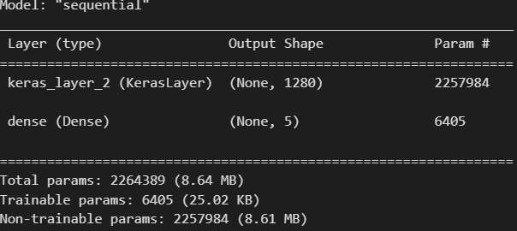

## Model Training

Next, we compile the model with our loss function set as categorical cross entropy, and Adam optimizer.

model.compile(

  optimizer="adam",

  loss=tf.keras.losses.SparseCategoricalCrossentropy(from_logits=True),

  metrics=['acc'])

Then we train the model using the fit() method:

model.fit(X_train_scaled, y_train, epochs=5)

on running

model.evaluate(X_test_scaled,y_test)

we find the accuracy to be 86.71% on the test set

### Prediction of a single image

We have an image(sun.jpg):

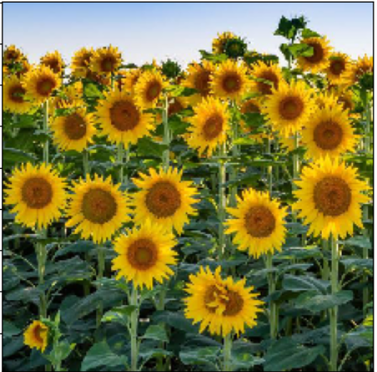

test_image_path = 'sun.jpg'

test_image = preprocess_image(test_image_path)

predictions = model.predict(test_image)

predicted_class = np.argmax(predictions, axis=1)

plt.imshow(np.squeeze(test_image))

print(f"Predicted class: {predicted_class}")

# Example class names (should match your dataset structure)

class_names = ['daisy', 'dandelion', 'roses', 'sunflowers', 'tulips']

print(f"Predicted flower: {class_names[predicted_class[0]]}")

Here, we pass a single image after applying the preprocessing function on it, to the model. We take argmax of the last layer’s logits to find the class to which the image belongs to.

(output)

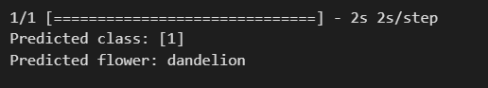

Github url : [IDL/Lab5 at main · HiddenMachine3/IDL (github.com)](https://github.com/HiddenMachine3/IDL/tree/main/Lab5)